

CSE 326

(PROJECT WORK)

On

**Property Based Work**

**SUBMITTED BY: SUBMITTED TO:**

**Someshwar Singh MRS. MANU BALI MAM**

**( 11910004,Roll No-46 )**

**Arbaas rahman**

**( 11917273,roll no.-47 )**

**Zeevan kumar Thakur (11918260 roll no.-48 )**

**In this project which is named as VEHICLE INSURANCE MANAGEMENT we are a group of 3 peoples helped each other in creating the website for this project.**

**ACKNOWLEGEMENT**

This project of HTML is for creating a web page for “Vehicle Insurance Management” and in this project ,we have used html and css, javascript for creating the webpage and we are responsible for whatever written here. And we hope our website will help in managing the events in a better way.

**WEBPAGE IS FOR?**

The ‘webpages’ objective of the project by designing a web page which contains the details of the vehicle customer which have purchase new vehicle or renew the insurance of the vehicle. The web page will contain some modules such as vehicle insurance type , different types of car,Policies ,,Claim etc.

|  |  |  |  |  |
| --- | --- | --- | --- | --- |
|  | The project what we have done consists of the details and it firstly asks the person to register or signup to enter in the home page of the website so that they can see the homepage of the Vehicle Insurance Management . |  | In this project we have tried to make a user friendly website by choosing appropriate background and modules arrangement so that they are truly interested to use this.  We have used animation which makes the webpage attactive.this all we have done by using html, css and javascript only. |  |

# Using of technical languages

We in this project have used mainly html and javascript so that we can make the website and that is what we have used in the complete code to interpret the code on notepad and saved in type of required extensions to use the webpage properly and that helped us more properly.

And another thing is we are providing the images of the website in the report so that the person who else read the report will properly get how the webpage look like.

**HOME PAGE design:**

**This page will provide the option of filling the registration form by the user.**

**Also it will allow the user to see event details , different type of cateogries and contact us page.**

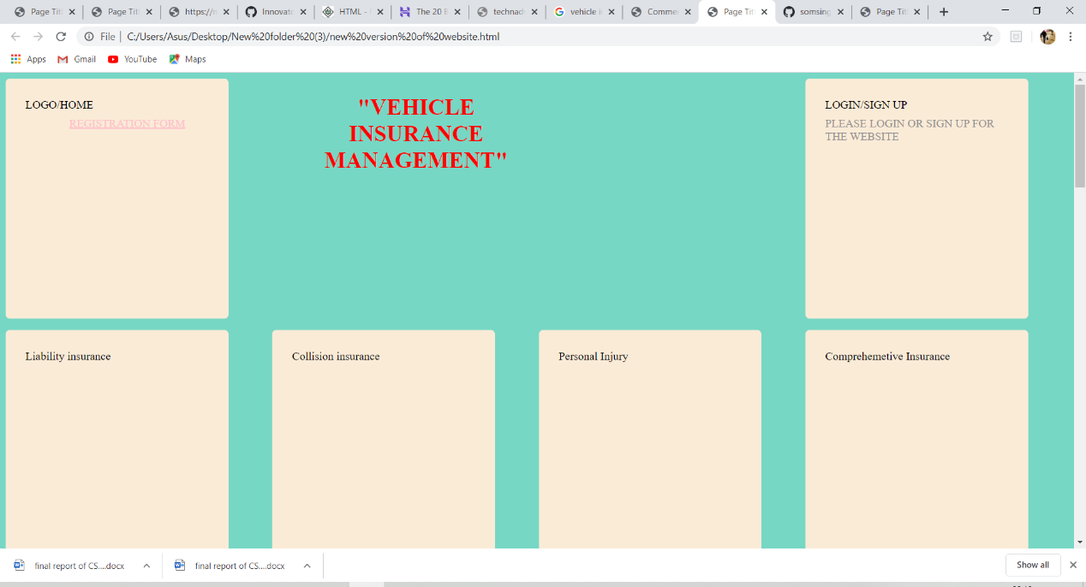

Here we can fill all deatil about the vehicles policy, product and also we can fill the buy new policy for our vehicles like car type, registration number ,different type of policy we can choose or fill in the given page.

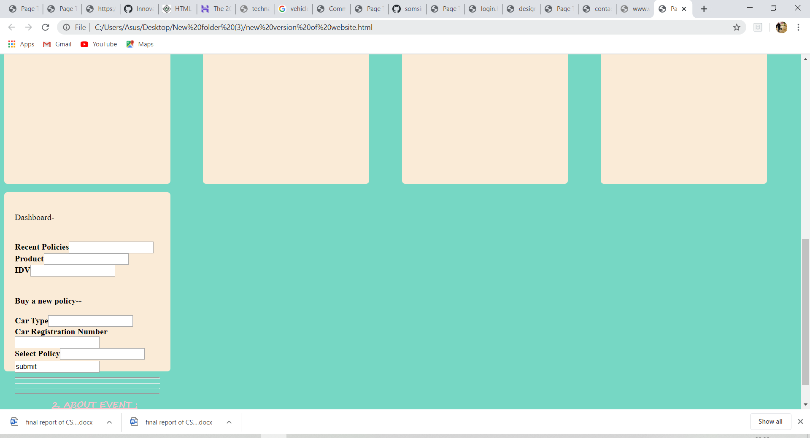

**This will be the first page of the website which will ask the user to fill some details like name and email id.**

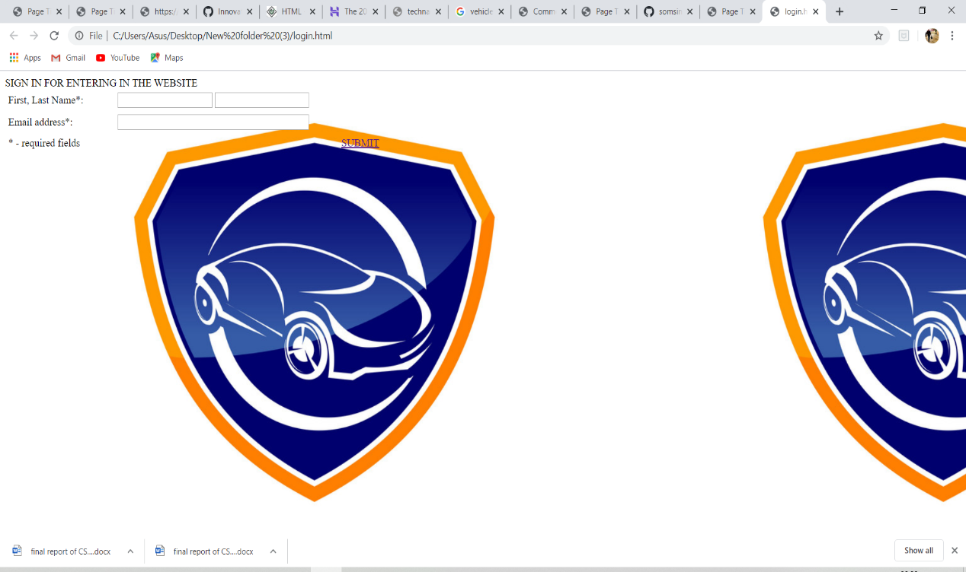

**When the user will fill the registration form for the feedback about the which is scheduled to be happen recently then following page will be open.**

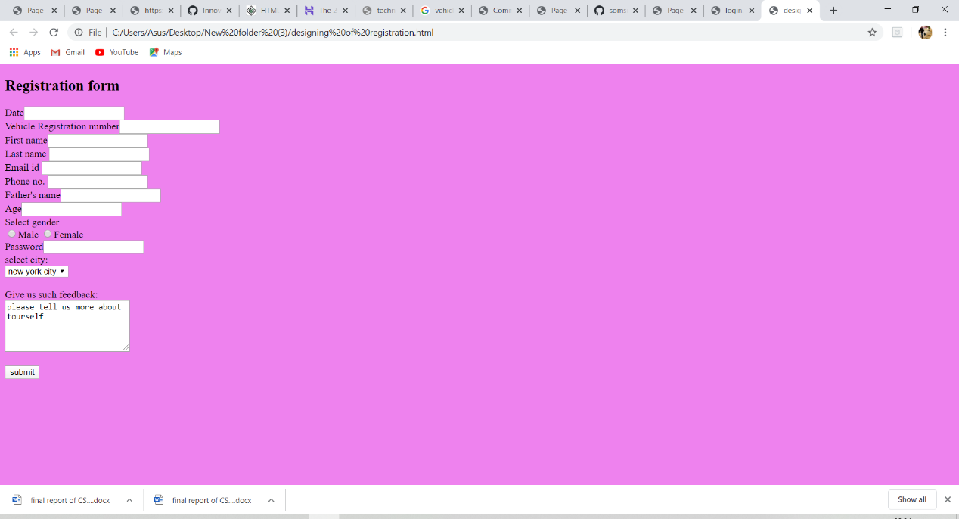

**This page will show about the company which always ready to provide help to customer in any where .**

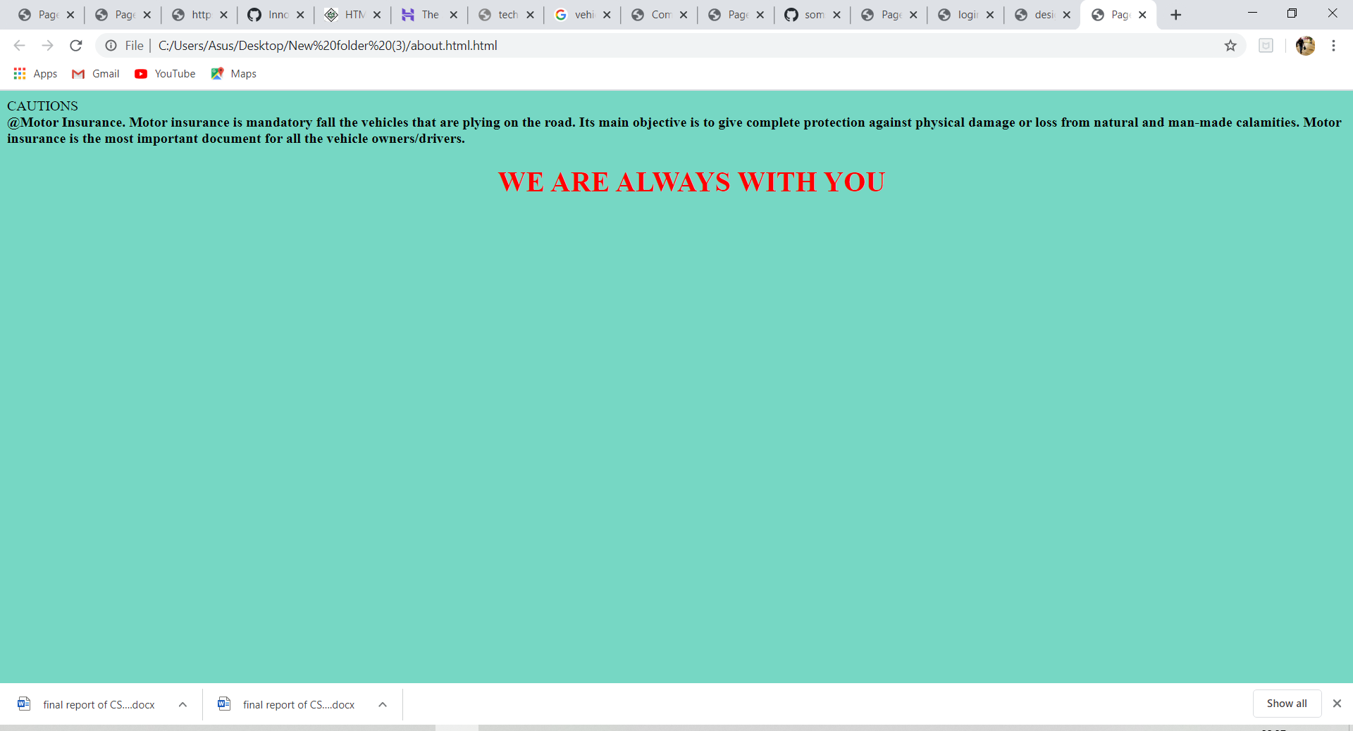

**Last but not the least if the user want to see the details about the event organiser , then below page will be open by clicking on module “contact us”.**

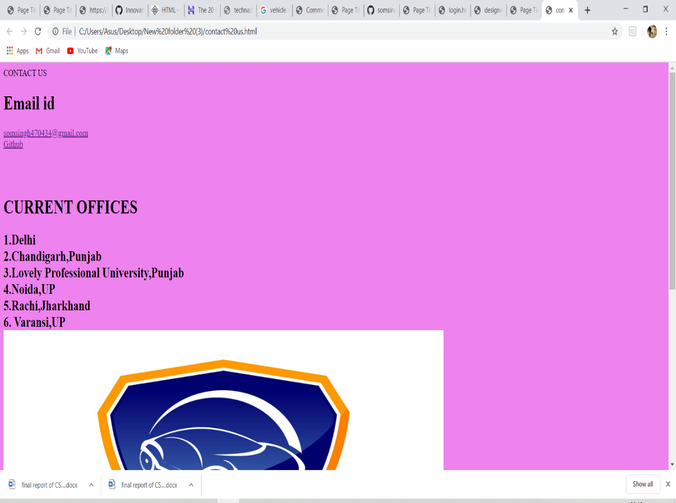

**This is all about the project……….**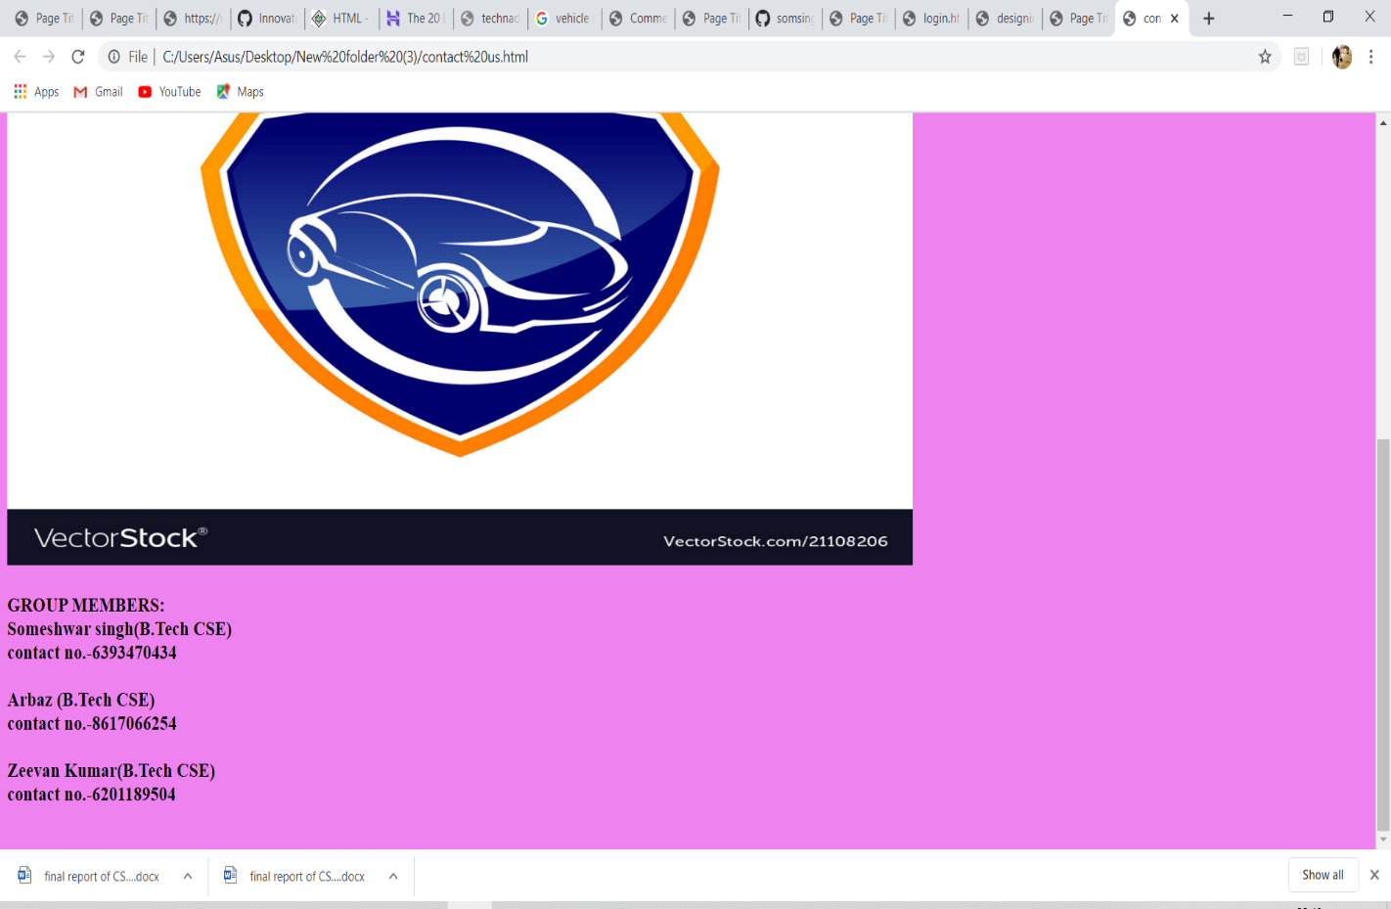

**Conclusions**—

The Insurance Management System In PHP is a simple mini project for keeping records of data of customers and agents. The project contains only the admin side. The admin has to manage all the management like adding customers, agents, policies, and premiums. Admin has an important role in the management of this system..It provides a new edge to management industry.It will help to stay digital in the new era of technolgy. It will give the complete information about the event to the user.It will also help in managing the events in different educational and non-educational institutions.

THANK YOU